Chapter 1

INTRODUCTION
  - Overview

Network administration tool is a software package that is designed specially for the administrators. This tool enables administrator to maintain software’s, control the access to network resources, file handling and helps in the handling of process execution, software maintenance on the client machines. The tool also helps to reduce the direct support provided for the network users by its special features.

Salient features:

    - The administrator can easily use the tool since it has a user-friendly GUI.

    - Supports software deployment on client machines remotely.

    - Simple and easier addition of new client machines.

    - Performs silent/quite tasks on the client machine.

    - Ease of installation/un-installation of software’s.

    - Reduction in the direct user support.

    - Can control the system operations from a single console

    - Maintain the software installed on the machine

    - Addition of new features to the tool is simple.

Multiple clients may connect to a NAT server at the same time. Popular uses for this technology include remote network administration, technical support and accessing files on one's work computer from one's home computer, or vice versa.

  - Motivation

A Network Administration Tool is designed for using within small, medium and corporate Offices with in a local area network (LAN). This Network Administration tool does not require internet connection, and it works across Ethernet

It would allow companies, organizations, educational institutions and dispersed workgroups to control all of its clients systems connected over on the network.

  - Objective

The main purpose of the project is to control all systems from a single centralised server which are connected on a network to perform day to day activities.
The objective of simulating the most basic feature for administrating the systems over a LAN
It provides the administrator the option to monitor the services, file handling, deployment of utilities and other administration activities on a number of client machines.

Chapter 2

VC ++

2.1 Visual Studio Highlights
This section contains information about some of the latest tools and technologies available in this release of Visual Studio.

2.1.1 Visual Studio Tools for Office
Microsoft Visual Studio 2005 Tools for the Microsoft Office System can help you create solutions by extending Word 2003 documents and Excel 2003 workbooks using Visual Basic and Visual C#. Visual Studio Tools for Office includes new Visual Studio projects for creating code behind Word documents, Word templates, Excel workbooks, and Excel templates. For more information, see Office Solutions Development Overview.

2.1.2 Visual Web Developer
Visual Studio features a new Web page designer named Visual Web Developer that includes many enhancements for creating and editing ASP.NET Web pages and HTML pages. It provides a simpler, faster way to create Web Forms pages than in Visual Studio .NET 2003.
Visual Web Developer features improvements in all areas of Web site development. You can create and maintain Web sites as local folders, in Internet Information Services (IIS), or on an FTP or SharePoint server. The Visual Web Developer designer supports all ASP.NET enhancements, including nearly two dozen new controls that simplify many Web development tasks. For more information, see What's New in Web Development for Visual Studio.

2.1.3 Smart Device Applications
The Visual Studio integrated environment includes tools for targeting devices such as PDAs and Smart phones. Improvements include Visual C++ tools and native device runtimes, managed designers that provide improved platform-specific WYSIWYG and multiple form factor support, a new emulator, data handling tools similar to the desktop, and end-user deployment projects that eliminate the manual editing of .inf files. For more information, see What's New in Smart Device Projects.

2.1.4 Web Forms
Web Forms are an ASP.NET technology that you use to create programmable Web pages. Web Forms render themselves as browser-compatible HTML and script, which allows any browser on any platform to view the pages. Using Web Forms, you create Web pages by dragging and dropping controls onto the designer and then adding code, similar to the way that you create Visual Basic forms. For more information, see ASP.NET Web Pages Overview.

2.1.5 Windows Forms
Windows Forms is for creating Microsoft Windows applications on the .NET Framework. This framework provides a clear, object-oriented, extensible set of classes that enables you to develop rich Windows applications. Additionally, Windows Forms can act as the local user interface in a multi-tier distributed solution. For more information, see Introduction to Windows Forms.

2.1.6 XML Web Services
XML Web Services are applications that can receive requests and data using XML over HTTP. XML Web Services are not tied to a particular component technology or object-calling convention and can therefore be accessed by any language, component model, or operating system. In Visual Studio, you can quickly create and include XML Web Services using Visual Basic, Visual C#, JScript, or ATL Server. For more information, see Introduction to Programming XML Web Services in Managed Code.

2.1.7 XML Support
Extensible Markup Language (XML) provides a method for describing structured data. XML is a subset of SGML that is optimized for delivery over the Web. The World Wide Web Consortium (W3C) defines XML standards so that structured data will be uniform and independent of applications. Visual Studio fully supports XML, providing the XML Designer to make it easier to edit XML and create XML schemas. For more information, see XML Designer.

2.2 Visual Studio Team System
Visual Studio 2005 Team System is a productive, integrated, and extensible software development life-cycle tools platform that helps software teams by improving communication and collaboration throughout the software development process. It consists of the following:
- Team Foundation is an extensible team collaboration server that provides work item
tracking, source control, reporting, and process guidance.
- Team Edition for Architects is a set of integrated application design tools for service-
oriented development.
- Team Edition for Developers provides code quality and performance tools that enable
teams to build reliable, mission-critical services and applications.
- Team Edition for Testers provides advanced load testing tools that enable teams to
verify the performance of applications before deployment.

2.3 The .NET Framework
The .NET Framework is a multi-language environment for building, deploying, and running XML Web Services and applications. It consists of three main parts:
- Common Language Runtime: Despite its name, the runtime actually has a role in both a component's runtime and development time experiences. While the component is running, the runtime is responsible for managing memory allocation, starting up and stopping threads and processes, and enforcing security policy, as well as satisfying any dependencies that the component might have on other components. At development time, the runtime's role changes slightly; because it automates so much (for example, memory management), the runtime makes the developer's experience very simple, especially when compared to COM as it is today. In particular, features such as reflection dramatically reduce the amount of code a developer must write in order to turn business logic into a reusable component.
- Unified programming classes: The framework provides developers with a unified, object-oriented, hierarchical, and extensible set of class libraries (APIs). Currently, C++ developers use the Microsoft Foundation Classes and Java developers use the Windows Foundation Classes. The framework unifies these disparate models and gives Visual Basic and JScript programmers access to class libraries as well. By creating a common set of APIs across all programming languages, the common language runtime enables cross-language inheritance, error handling, and debugging. All programming languages, from JScript to C++, have similar access to the framework and developers are free to choose the language that they want to use.
- ASP.NET ASP.NET builds on the programming classes of the .NET Framework, providing a Web application model with a set of controls and infrastructure that make it simple to build Web applications. ASP.NET includes a set of controls that encapsulate common HTML user interface elements, such as text boxes, buttons, and list boxes. These controls run on the Web server, however, and render their user interface as HTML to the browser. On the server, the controls expose an object-oriented programming model that brings the richness of object-oriented programming to the Web developer. ASP.NET also provides infrastructure services, such as state management and process recycling, that further reduce the amount of code a developer must write and increase application reliability. In addition, ASP.NET uses these same concepts to enable developers to deliver software as a service. Using XML Web Services features, ASP.NET developers can write their business logic and use the ASP.NET infrastructure to deliver that service via SOAP. For more information, see Introduction to Programming XML Web Services in Managed Code.

2.4 VC++

Developing in Visual C++ is a large and complex subject, as it provides a much lower level of interaction with the underlying Windows APIs and COM APIs when compared to other development environments.
While this can be a hindrance for rapid application development, it is the most flexible approach. A number of design patterns, such as COM aggregation and singletons, that are possible in Visual C++ are not possible in Visual Basic 6. By using standard class libraries, such as ATL, the complex COM plumbing code can be hidden. However, it is still important to have a thorough understanding of the underlying ATL COM implementation.
The documentation in this section is based on Microsoft Visual C++ version 6 and provides some guidance for ArcGIS development in this environment. With the release of Visual Studio C++ .NET (also referred to as VC7), many new enhancements are available to the C++ developer. While VC7 can work with the managed .NET environment, and it is possible to work with the ArcGIS .NET API, this will only add overhead to access the underlying ArcGIS COM objects. So for the purposes of ArcGIS development in VC7, it is recommended to work the "traditional" way, that is, directly with the ArcGIS COM interfaces and objects.
With the addition of the Visual C# .NET language, it is worth considering porting Visual C++ code to this environment and using the ArcGIS .NET API. The syntax of C# is not unlike C++, but the resulting code is generally simpler and more consistent.
This section is intended to serve two main purposes: to familiarize you with general Visual C++ coding style and debugging, beginning with a discussion on ATL, and to detail specific usage requirements and recommendations for working with the ArcObjects programming platform in Visual C++.

2.5 Information on Visual C++
Microsoft Visual C++ v6.0 provides a rich set of features that can help you as you write and test code for your programming assignments this term. The brief tutorial on this page is designed to step you through the basics of creating and running a new program using Visual C++ so that you can begin to get comfortable using the tool.
In this tutorial, we will build and run a simple program that involves a single C++ class. Our program will include a main() function that creates an object of this class and calls a couple of methods on the object before exiting. Once you get up and running with the example presented here, I encourage you to take some time to explore other features of Visual C++ on your own.

Step 1: Creating a new project
The set of files that constitutes a program in Visual C++ is organized into a unit called a "project". So to start working on a new program, you must create a new project to store your files. To do this, start Visual C++ and then choose File / New from the menu. You will see a dialog box appear that looks like this:
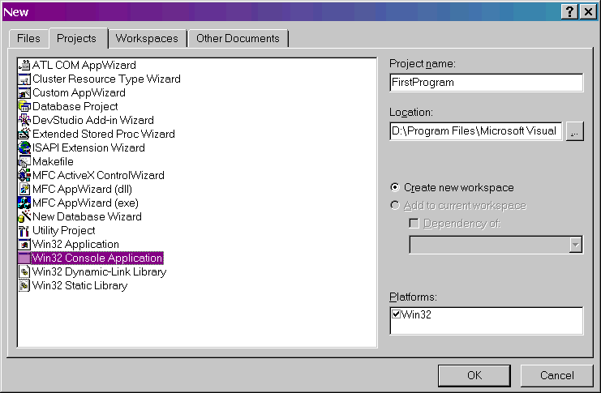

In this dialog, select "Win32 Console Application" as the project type and give the project a name of "FirstProgram" as shown above. Set the Location field to the directory that you want to contain your project directory. Once you've changed these settings, click OK to get to the next dialog box, which looks like this:
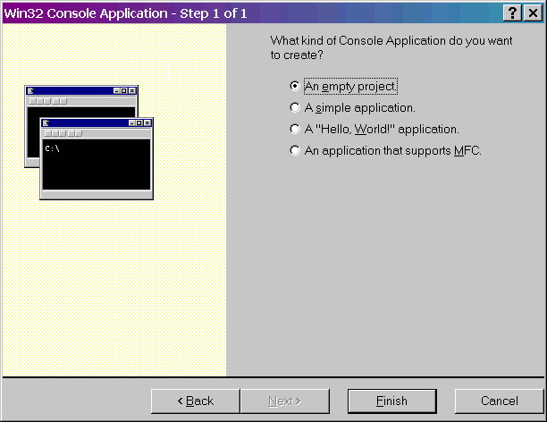
Select "An empty project" from the list of choices, and then click on Finish. Next, click OK on the confirmation window that appears.
Congratulations! You've just created a new project.

Step 2: Add a class to the project
Now it's time to add a class to your project. We will implement a simple class called CMyClass. This class will contain one integer as a member variable and will provide two methods to get and set the value of this integer.
Visual C++ includes wizards that can automate some of the process of adding a new class to the project. But since it is important for you to understand what goes on behind the scenes, we will add and edit the class files manually.
Remember, each C++ class requires a header file (.h) that contains the definition of the class and an implementation file (.cpp) that contains the actual bodies of the methods. We'll create the header file first. Choose File / New from the menu again. Since a current project already exists, you get a different dialog box now, which looks like this:
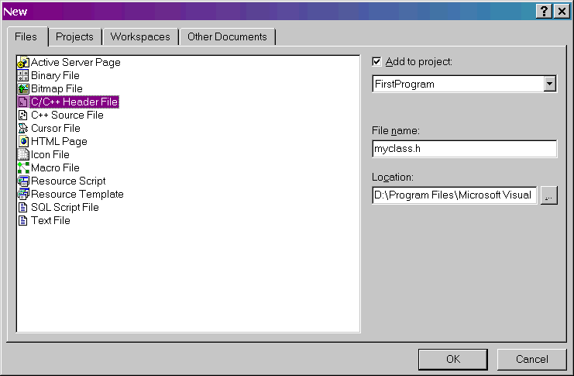

Choose "C/C++ Header File" as the file type and give the file a name of "myclass.h" as shown above. (The rest of the settings can remain at their defaults.) Click OK and you will see a blank file appear in the main window called "myfile.h". Enter the following code into this window:
#ifndef MYCLASS_H
#define MYCLASS_H

class CMyClass {
public:
void setValue(int value);
int getValue();
private:
int m_value;
};

#endif
This code defines our simple class including the integer attribute and the accessor methods for changing its value. Save the file by hitting CTRL-S before proceeding.
Now we need to add another file to contain the implementation of our class methods. Go back to the File / New menu to bring up the new file dialog. This time, choose "C++ Source File" as the file type and name it "myclass.cpp". Click OK and, again, you will see a blank file appear in the main window. Enter the following code into this window:

#include "myclass.h"

int CMyClass::getValue() {
return m_value;
}

void CMyClass::setValue(int value) {
m_value = value;
}
Save the file. Congratulations! You've now added a class to your project. Notice if you expand the tree control in the left-hand window pane as shown below, you can see a graphical representation of your class:

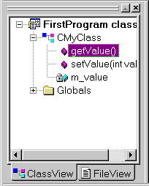
If you double-click on the class name (CMyClass) or an attribute, Visual C++ will automatically show the class header file in the main window area. If you double-click on a method, the class implementation file will appear.

Step 3: Enter the program

Step 4: Build and run the project
You're now ready to test the program. Compile and link it by selecting Build / Build FirstProgram.exe from the menu. If you get any errors or warnings, double-check your code for typing mistakes.
Next, choose Build / Execute FirstProgram.exe from the menu to run the program. If you see output that resembles the following, you have successfully built and run your program:

Step 5: Debugging your code
Visual C++ provides an excellent graphical debugger that can help you correct problems in your code. Let's test it out using the simple program we just developed.

Part 1: Stepping through code
Stepping (or "tracing") through code line by line as it executes is a great way to uncover bugs. Visual C++ allows you to do this, and let's you examine the state of the program as it's running. You can check the values of local variables, object member variables, and the call stack, among other things.
To start tracing through your program, press the F11 key. The Visual C++ interface will change to something resembling the following:

Notice the yellow arrow next to the beginning of the main() function. The arrow marks the next line of code that the computer will execute, which is the first line of the program in this case.
There are two important shortcut keys to keep in mind when stepping through code: the "Step Into" key (F11) and the "Step Over" key (F10). When the arrow points to a line that contains one or more function calls, the Step Into key tells the debugger to step into the function that is being called. In other words, pressing F11 causes the debugger to move the arrow to the first line of function being called so that you can step through that function's code. In contrast, the Step Over key tells the debugger to execute the function without stepping through its code. In other words, pressing F10 causes the debugger to move the arrow to the next line of the current function.
Try stepping through the code of your program several times using the F10 and F11 keys to get used to the difference between then. Specifically, try stepping into the two methods, getValue() and setValue().
Caution: If you select Step Into at certain lines of code (such as the cout line) you might see some strange C++ code or even assembly language appear on the screen. What you are actually seeing is the code that Visual C++ uses internally to support your program. If you get into this situation, you can try pressing SHIFT-F11. (SHIFT-F11 is the "Step Out" key, which returns you to the function that called the current function.) If you get really lost, you can also press F5, which will cause the debugger to run the program from your current position without stepping. Similarly, SHIFT-F5 will stop the program completely.
Hint: When you reach the last line of your main() function (i.e. the closing brace), always hit F5 to finish the program off. Otherwise, Visual C++ will try to step through some of its own clean-up code.

Part 2: Examining the values of variables
As you step through code, you may notice that the bottom left-hand section of the debugger interface shows you the values of variables that have recently been changed. For example, when the program reaches the point shown below, you can see that the variable called "var" has just been assigned the value 200:

This is called the Variables window and it has three modes, which you can select by clicking on the tabs below the window. In "Auto" mode, the window shows the values of variables that recently changed or the output of recent function calls. In "Locals" mode, the window shows the values of all local variables. In "this" mode, the window shows the value of all member variables of the current object. Note that you can also change the values of the variables at run-time using this window, too.

Part 3: Using breakpoints
If you want to run your program up to a certain point without stepping through all the code before that point, you can define "breakpoint" lines. To set a breakpoint, right-click on a line of code in your program and choose Insert/Remove Breakpoint from the menu. A red dot will appear next to the line with the breakpoint. In the example below, I've set a breakpoint at the cout line:

Once you've set one or more breakpoints, select Build / Start Debug / Go from the menu or press F5. Your program will run until it hits the line of code with the breakpoint, and then pauses. You can now step through the code and examine variables as you wish.

2.6 SOCKETS

2.6.1 Introduction
Most operating systems provide precompiled programs that communicate across a network. Common examples into the TCP/IP world are web clients(browsers) and web servers, and the FTP and TELNET clients and servers. Sometimes when we are using this utilities of the internet we don't think about all the process involved. To better understand this aspects we, in our research group(GTI, Grupo de Tecnologia em Informática) at Goias Catholic University (Universidade Católica de Goiás), decide to build, write our own network programs, mini-chat, using the basic structure about sockets, an application program interface or API, that mechanism that make all this communication possible over the Net.
We examine the functions for communication through sockets. A socket is an endpoint used by a process for bi-directional communication with a socket associated with another process. Sockets, introduced in Berkeley Unix, are a basic mechanism for IPC on a computer system, or on different computer systems connected by local or wide area networks(resource 2). To understand some structs into this subject is necessary a deeper knowledge about the operating system and his networking protocols. This subject can be used as either beginners programmers or as a reference for experienced programmers.

2.6.2 Socket Programming Techniques
This is an introduction to socket programming. The language will be Java, which is fast becoming the dominant language of the Networking world. Java allows a person to write and compile a program on a platform such as Windows 95, and take that code and run it without any changes on a Macintosh, Unix, Linux or Windows NT machine. That is why Microsoft are so afraid of the power of Java and have tried to stop Java from becoming the language for Network programming.
What is a Socket
The socket is the method for accomplishing interprocess communication (IPC). What this means is a socket is used to allow one process to speak to another, very much like the telephone is used to allow one person to speak to another.
The telephone analogy is usually a good one, and will be used repeatedly to describe socket behavior.
How to listen for socket connections
In order for a person to receive telephone calls, he must first have a telephone installed. Likewise you must create a socket to listen for connections. This process involves several steps. First you must make a new socket, which is similar to having a telephone line installed. The socket() command is used to do this.
Since sockets can have several types, you must specify what type of socket you want when you create one. One option that you have is the addressing format of a socket. Just as the mail service uses a different scheme to deliver mail than the telephone company uses to complete calls, so can sockets differ. Sockets are useed for IPC between processes on the same machine. Socket addressing uses Internet addresses which are four-byte numbers usually written as four decimal numbers separated by periods (such as 192.9.200.10). In addition to the machine address, there is also a port number which allows more than one socket on each machine.
Another option which you must supply when creating a socket is the type of socket. The type that we will use here is the Datagram type. Datagram indicates that data will come in bunches (called datagrams). Streaming is another type.
We create a socket as follows:
DatagramSocket s = new DatagramSocket();
This is so much more easier than in C code. 1 line! After creating a socket, we Client part of the code (only) must give the socket an address to listen to, just as you get a telephone number so that you can receive calls.
int port = Integer.parseInt(argv[1]);
InetAddress in[] = InetAddress.getAllByName(argv[0]);
The above sample piece of code is used to do this (it binds a socket to an address).
Sockets have the ability to queue incoming connection requests, which is a lot like having "call waiting" for your telephone. If you are busy handling a connection, the connection request will wait until you can deal with it.
byte buf[] = new byte[10];
DatagramPacket dp = new DatagramPacket(buf, 10);
The above piece of code creates a buffer (10 in length) and waits for incoming messages to fill the buffer.
After you create a socket to get calls, you must wait for calls to that socket. The receive() function is used to do this. Calling receive() is analogous to picking up the telephone if it's ringing. receive() returns a new socket which is connected to the caller.
The following function can be used to accept a connection on a socket that has been created using the DatagramSocket code above:
s.receive(dp);
Unlike with the telephone, you may still accept calls while processing previous connections. For this reason you usually fork off jobs to handle each connection. You would use threads for this, however we do not need to concern ourselves with this at this stage.

How to call a socket
You now know how to create a socket that will accept incoming calls. So how do you call it? As with the telephone, you must first have the phone before using it to call. You use the inetaddress() function to do this, exactly as you establish a socket to listen to.
After getting a socket to make the call with, and giving it an address, you use the DatagramSocket()() function (yet again) to try to connect to a listening socket. The following code, creates a socket, binds to the Internet address where the Server is listening and then calls a particular port number on a particular host:
int port = Integer.parseInt(argv[1]);
InetAddress in[] = InetAddress.getAllByName(argv[0]);
DatagramSocket s = new DatagramSocket();
The above code basically returns a connected socket through which data can flow between client and server. It is basically creating a pipe between two processes.

How to talk between sockets
Now that you have a connection between sockets you want to send data between them. The receive() and send() functions are used to do this, just as they are for normal files.
The code to send in Java is as follows: s.send(dp);
There is only one major difference between socket reading and writing and file reading and writing: you don't usually get back the same number of characters that you asked for, so you must loop until you have read the number of characters that you want. A simple function to read a given number of characters into a buffer is:
Server Sample Code:
for (int i=0; i<buf.length; ++i) System.out.println(buf[i]);

Client Sample Code:
for (int i=0; i<buf.length; ++i) buf[i] = (byte)i;

What to do when you're done with a socket
Just as you hang up when you're through speaking to someone over the telephone, so must you close a connection between sockets. The normal close() function is used to close each end of a socket connection. If one end of a socket is closed and the other tries to write to its end, the write will return an error. The code to close a socket in Java is :
s.close();

2.6.3 The Socket Function
Most network applications can be divided into two pieces: a client and a server.
Creating a socket
#include <sys/types.h>
#include <sys/socket.h>
When you create a socket there are three main parameters that you have to specify:
- the domain
- the type
- the protocol
int socket(int domain, int type, int protocol);
The Domain parameter specifies a communications domain within which communication will take place, in our example the domain parameter was AF_INET, that specify the ARPA Internet Protocols The Type parameter specifies the semantics of communication, in our mini chat we used the Stream socket type(SOCK_STREAM), because it offers a bi-directional, reliable, two-way connection based byte stream(resource 2). Finally the protocol type, since we used a Stream Socket type we must use a protocol that provide a connection-oriented protocol, like IP, so we decide to use IP in our protocol Type, and we saw in /etc/protocols the number of ip, 0. So our function now is:
s = socket(AF_INET , SOCK_STREAM , 0)
where 's' is the file descriptor returned by the socket function.
Since our mini chat is divided in two parts we will divided the explanation in the server, the client and the both, showing the basic differences between them, as we will see next.

2.7 The Mini-chat Server structure

2.7.1 Binding a socket to a port and waiting for the connections
Like all services in a Network TCP/IP based, the sockets are always associated with a port, like Telnet is associated to Port 23, FTP to 21... In our Server we have to do the same thing, bind some port to be prepared to listening for connections ( that is the basic difference between Client and Server), Listing 2. Bind is used to specify for a socket the protocol port number where it will be waiting for messages.
So there is a question, which port could we bind to our new service? Since the system pre-defined a lot of ports between 1 and 7000 ( /etc/services ) we choose the port number 15000.
The function of bind is:
int bind(int s, struct sockaddr *addr, int addrlen)
The struct necessary to make socket works is the struct sockaddr_in address; and then we have the follow lines to say to system the information about the socket.
The type of socket
address.sin_family = AF_INET /* use a internet domain */

The IP used
address.sin_addr.s_addr = INADDR_ANY /*use a specific IP of host*/
The port used
address.sin_port = htons(15000); /* use a specific port number */
And finally bind our port to the socket
bind(create_socket , (struct sockaddr *)&address,sizeof(address));
Now another important phase, prepare a socket to accept messages from clients, the listen function is used on the server in the case of connection oriented communication and also the maximum number of pending connections(resource 3).
listen (create_socket, MAXNUMBER)
where MAXNUMER in our case is 3. And to finish we have to tell the server to accept a connection, using the accept() function. Accept is used with connection based sockets such as streams.
accept(create_socket,(struct sockaddr *)&address,&addrlen);
As we can see in Listing 2 The parameters are the socket descriptor of the master socket (create_socket), followed by a sockeaddr_in structure and the size of the structure.(resource 3)

2.7.2 The Mini-chat Client structure
Maybe the biggest difference is that client needs a Connect() function. The connect operation is used on the client side to identify and, possibly, start the connection to the server. The connect syntax is
connect(create_socket,(struct sockaddr *)&address,sizeof(address)) ;

2.7.3 The common structure
A common structure between Client and the Server is the use of the struct hostent as seeing in Listing 1 and 2. The use of the Send and Recv functions are another common codes.
The Send() function is used to send the buffer to the server
send(new_socket,buffer,bufsize,0);
and the Recv() function is used to receive the buffer from the server, look that it is used both in server and client.
recv(new_socket,buffer,bufsize,0);

Chapter 3

SOFTWARE REQUIREMENTS SPECIFICATIONS

The software specification document is a description of the system requirements. The software requirements document is not a design document. It should set out what the system should do without specifying how it should be done. The requirements should be stated so that there is trace ability between these requirements and the final system design. This means that it should be possible to take each specified requirement and map it onto the part of the system design that implements that requirement. If the services, Constraints and properties specified in the software requirement document are satisfied by the software design then that design is an acceptable solution to the problem.

  - Purpose And Scope

The software requirement specification (SRS) is the official statement of what is required of the system developers. It includes both the user and system requirement.

User Requirement:

The user requirement for a system describes the functional and non-functional requirement so that they are understandable by system users who don’t have detailed technical knowledge. The user requirement must be written using natural language, forms and simple intuitive diagrams.

System Requirement:

These are more detailed description of the user requirements. They are used by software engineers as a starting point for system design. The System requirement specification may include different models of the system such as an object model or a data-flow model. In principal, the system requirement states what the system should do and not how it should be implemented.

Functional Requirement:

This describes the functionality or services that the system is expected to provide. In principal, the functional requirement specification of a system should be both complete and consistent.

Non-Functional Requirement:

These are requirements which are not directly concerned with the specific functions delivered by the system. They may relate to emergent system properties such as reliability, response time etc.

Domain Requirements:

These are the requirements that come from the application domain of the system and that reflect characteristics of that domain. They may be functional or non-functional requirements. These requirements are important because they often reflect fundamentals of the application domain. If these requirements are not satisfied, it may be impossible to make the system work satisfactorily.

  - Functional Requirements

The NAT tool is intended to be useful for administration clients on a network. It should help the network administrator to maintain the systems on the network.

- It should have an easy to read, and very configurable GUI.
- It should detect OS's, sessions, hostnames, open ports etc.
- It should collect and report network statistics.

  - Non-Functional Requirements

When it comes for the network in computer terminology we should consider specially the performance issues. NAT should be implemented with this consideration

- It should have a good performance and should utilize less network traffic.
- All the errors should be written into the log.
- It should have a very simple GUI, so training time for users will be less.
- It should consume very less system resources.

  - Hardware Specifications

- Processor: Pentium4 processors with 2.66GHz. (2 CPUs or more)
- Hard Disk: 40 GB
- RAM: 256 MB
- 10/100 NIC (Network Interface Card)
- Modem: 256Kbps (Optional)
- Wireless NIC (Optional)

  - Software Specifications
- OS: Microsoft Windows XP with Service Pack 2
- Programming Language: Microsoft Visual C++ 6.0

Chapter 4

SYSTEM ANALYSIS

4.1 Current Scenario

An Intranet provides access to information quickly and easily in a familiar environment, while keeping this information securely off the public internet. It also facilitates interdepartmental cooperation. The NAT is designed to work on LAN. The NAT can be used within small, medium local area networks.

- The NAT does not require any Internet connection, and it works across Ethernet port using TCP/IP protocol.
- It allows companies, organizations, educational institutes and dispersed workgroups to control the clients, administer them remotely.
- There is only one user logged onto one system. The users are identified by their system IP address.
- The server is bound to a fixed socket port and listens for connection requests from clients. The clients try to connect to server on this port and predefined host. The clients after sending a connection request and subsequently establishing a connection with the corresponding server sends the request for required service.
- Since it runs over TCP, it transfers data reliably, and efficiently.
4.2 Limitations
- Requires Administration access
- Firewall must be disabled
- Deployment of utilities on
- Supports only Windows Operating System
4.3 Feasibility Study
All projects are feasible given unlimited time and resources. Unfortunately, the developments of computer based system are more likely to be plagued by scarcity of resources and difficult delivery dates. It is both necessary and prudent to evaluate the feasibility of projects at the earliest possible time. Months or years of efforts, thousands or millions of rupees and unfold professional embarrassment can be averted if an ill-conceived system recognized early in the development process/phase.

A detailed study is carried out to check the workability of the proposed system. So, the feasibility study is a system proposal regarding the workability, impact on the organization’s ability to meet the user needs and effectiveness use of resources. During the feasibility analysis of the project, the following points were taken under consideration.

Preliminary investigation examines project feasibility. Three tests of feasibility- all equally important were studied:

- Operational Feasibility
- Technical Feasibility
- Schedule Feasibility

4.3.1 Operational Feasibility

Operational feasibility covers two aspects. One is technical performance aspect and the other is the acceptance. Technical performance includes issues such as determining whether the system is working correctly without corrupting or badly affecting any other application and it should be tested to see that it meets all the specified requirements. Acceptance revolves around the current system and its personnel. As animation production management software is used by many companies across the world it should certainly be very useful to them.
4.3.2 Technical Feasibility
The system we developed should be technically feasible. The resources available on the system itself, the services that can be provided by the connecting network and the time that the entire operation takes should be acceptable and permissible by users at both the server and the client end.

4.3.3 Schedule Feasibility
An evaluation of time has to be taken in account for the development of the project. The time schedule required for the development of the project is very important since the more time it takes, the time, cost and delay of the development of the system is affected. So the project should be completed within a fix schedule as far as the company is concerned. Even though it is necessary to complete our project within stipulated time we can continue working for the project if we are really interested in it.
4.4 Pre-requisites
- Network should be available
- It should be allowed through the firewall
- NAT Agent should available in the same folder where the server application is.

Chapter 5

SYSTEM DESIGN

5.1 Introduction

System design is a modeling process. It is a solution, how to approach to create a new system. It can be defined as a transition from user’s view to programmer’s or database person’s view. The design phase mainly depends on the detailed specification in the feasibility study. The system design phase acts as a bridge between the required specification and the implementation phase.

From a project management point of view software design is conducted in two steps. Preliminary design is concerned with the transformation of requirements into data and software architecture. Detailed design focuses on refinement to the architectural representation that leads to detailed data structure and algorithmic representation for software.

The major steps in the design phase are input design, output design, and dealing with coding issue. The very first step is design of input and out put screen to the client requirements. Next comes the various issues that should be dealt while coding and the code should be such that it should be compatible with the real time environment and should be generic in nature.

This model takes the fundamental process activities of specification, development, validation and evolution and represents them as separate process phases.
REQUIREMENTS DEFINITION

SYSTEM AND SOFTWARE DESIGN
IMPLEMENTATIONNN AND UNIT TESTING

INTEGRATION & SYSTEM TESTING

OPERATION AND MAINTENANCE

Figure 4.1 The schematic representation of waterfall model.

5.2 Modular Decomposition

After a structural architecture has been designed, the next stage of the architectural design process is the decomposition of sub-system into modules. Usually two models are used for this purpose: An object-oriented model and a data flow model.

In object-oriented model the system is decomposed into a set of communicating objects. In data flow model the system is decomposed into functional modules which accept input data and transform it, in some way, to output data.

In this project the modules are divided into NAT Agent and NAT GUI. The GUI is for server machine which enables the network administrator to control various activities on the client machines. Agent module is installed on the client machine. These two modules communicate with each other to perform the activities.

The GUI module is designed using Win32 SDK. The client/server communication uses socket programming. The NAT Agent retrieves the system information using WIN32 API’s. This combination of these two enables comfortable environment for developing the modules.
Chapter 6

IMPLEMENTATION

6.1 Deployment of NAT in the Network Architecture

6.1.1 Shared network

A shared network is also known as hubbed network which is connected with a hub. Hubs are commonly used to connect segments of a LAN. When a packet arrives at one port, it is copied to the other ports so that all segments of the LAN can see all packets. A passive hub serves simply as a conduit for the data, enabling it to go from one device (or segment) to another. So-called intelligent hubs include additional features that enable an administrator to monitor the traffic passing through the hub and to configure each port in the hub. Intelligent hubs are also called manageable hubs. A third type of hub, called a switching hub, actually reads the destination address of each packet and then forwards the packet to the correct port.

With a shared environment, NAT can be installed on any host in LAN. The entire network data through the Hub will be captured, including the communication between any two hosts in LAN.

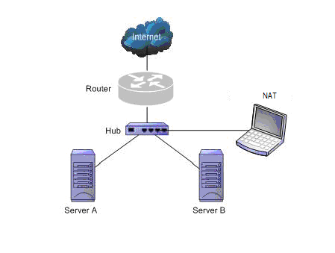
Fig. 4.1: NAT implementation using a hub

6.1.2 Switched network

Switch is a network device working on the Data Link Layer of OSI. Switch can learn the physical addresses and save these addresses in its ARP table. When a packet is sent to switch, switch will check the packet’s destination address from its ARP table and then send the packet to the corresponding port.

6.1.2.1 Network with manageable switches

Generally all three-layer switches and partial two-layer switches have the ability of network management; the traffic going through other ports of the switch can be captured from the debugging port (mirror port/span port) on the core chip. To analyze the traffic going through all ports, During this situation also NAT can be installed on nay of the client or an server machine.

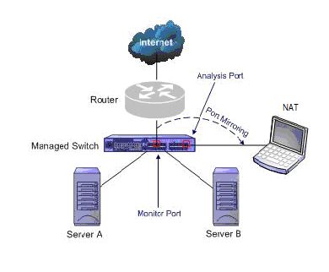

Fig. 4.2: NAT implementation using manageable switch

6.1.2.2 Network with unmanageable switches

Taps can be flexibly placed on any line in network. When the requirement for network performance is very high, you can add a tap to connect your network.

NAT implementation using an unmanageable switch is as shown in the Fig. 4.7

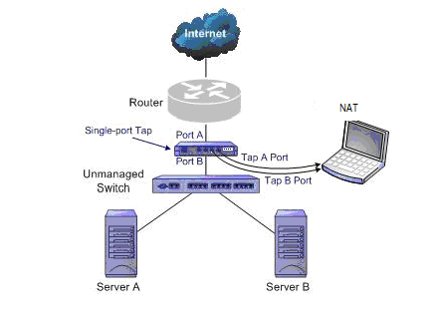
Fig. 4.3: NAT implementation using tap

6.2 A Typical Client-Server Architecture

Large systems are always decomposed into sub-systems that provide some related set of services. The initial design process of identifying these sub-systems and establishing a framework for sub-system control and communication is called architectural design and the output of this design process is a description of the software architecture.

The architecture design process is concerned with establishing a basic structural framework for a system. It involves identifying the major components of the system and the communication between these components.

In this project the basic components required are the machines with the minimal software and hardware requirements connected via cables to form a network. The system on which the tool is installed acts as the server. The other machines are considered to be clients.

As a result, the software architecture states that the separate modules are required to perform activities on server and client machines.

6.2.1 Client Server Architecture :

A network architecture in which each computer or process on the network is either a client or a server. Each client or server connected to the network can be referenced as a node. The most common type of client server architecture includes only two types of nodes: client and server. This type of architecture is sometimes called 2-tier architecture. The 2-tier architecture makes possible the sharing of files and resources between devices connected to the computer network.
The client-server model has become one of the central ideas of network computing. Many business applications being written today use the client-server model. So do the Internet's main application protocols, such as HTTP, SMTP, Telnet, DNS. In marketing, the term has been used to distinguish distributed computing by smaller dispersed computers from the "monolithic" centralized computing of mainframe computers. But this distinction has largely disappeared as mainframes and their applications have also turned to the client-server model and become part of network computing.

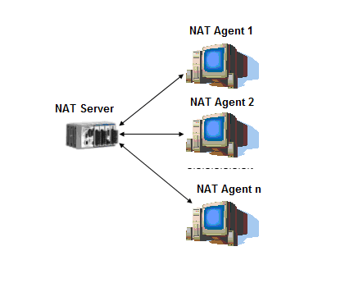
Fig 1: Client Server Architecture.

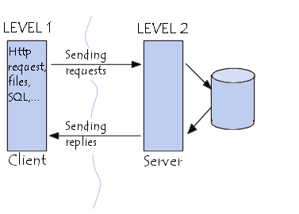

Fig: 2: Tier Architecture

Client
A client is a computer that requests a service of a server. The service can be localized in other computer or in the same computer that requests the service, that is, the client computer can act as a server too.
Access to the service is available through some type of interface.
Types of clients:
- Web browser - a web browser is a software application that enables a user to display and interact with text, images, videos, music and other information typically located on a web page at a website on the world wide web or a local network.
- Email client - an e-mail client, also known as mail user agent (MUA) is a frontend computer program used to manage email. Sometimes, the term e-mail client is also used to refer to any agent acting as a client toward an e-mail server, independently of it being a real MUA, a relaying server, or a human typing directly on a terminal. In addition, a web application such as the Gmail from Google providing the relevant functionality is sometimes considered an email client.
- Online chat client - an online chat client or instant messaging client is a software application that enables the user to engage in instant messaging.

Server:
A server is a computer that accepts connections to serve the requests of client computers. The server sends responses to the client computers. A server is generally connected to a computer network.
Types of servers:
The most common types of servers are:
- Application server - a computer with a software engine that delivers applications to client computers or devices, typically through the Internet and using the hyper text transfer protocol (HTTP). The application server handles most, if not all, of the business logic and data access of the application.
- Backup server - a computer responsible for safekeeping important business files, financial records, and personal music and pictures so that in case of the original files be deleted there will still exist a copy.
- Database server - a computer responsible for the provisioning of database services to other computer programs or computers. Database servers store the database on a dedicated computer system, allow it to be accessed concurrently, maintain the integrity of the data, and handle transaction support and user authorization. A database server divides an application into a front end and a back end, in accordance with the client-server model. The front end runs on the client computer and displays the requested data. The back end runs on the server and handles tasks such as query processing, data analysis and storage.
- DHCP server - a computer that provides the dynamic host configuration protocol (DHCP) service on the network that assigns network addresses to other devices, such as a telephone and computer.
- DNS server - a computer that provides the domain name service (DNS) which translates the names of sites into their numerical addresses, that is, resolves the name of the website typed into the location field of the browser with the Internet protocol (IP) address of the server that will send the requested information from that website.
- Domain server - a computer that holds all the records associated with a particular domain and answers queries about those records.
- Email server - a computer acting as a mail transfer agent (MTA) or SMTPD (SMTP daemon) that is running the appropriate software. This computer is responsible for transferring the electronic mail messages from one computer to another.
- File server - a computer responsible for the central storage and management of data files so that other computers on the same network can access those files.
- Firewall server - designed to secure an internal network from threats and attacks that come from the Internet offering powerful and flexible control over all inbound and outbound network traffic.
- FTP server - a computer that runs a program that can receive requests for a file transfer protocol (FTP) link from a client computer.
- Logon server - a computer responsible for authenticating client computers in a domain.
- Print server - a computer to which one or more printers are connected, which can accept print jobs from external client computers connected to the print server over a network. The print server then sends the data to the appropriate printer that it manages.
- Proxy server - a computer system or an application program which services the requests of its clients by forwarding requests to other servers. A client connects to the proxy server, requesting some service, such as a file, connection, web page, or other resource, available from a different server. The proxy server requests the service on behalf of the client between an internal network of an organization and the Internet as part of a security system to protect the organization's network of external intrusion.
- Security server - a computer dedicated to provide security policy decisions and to enforce such decisions.
- Terminal server - a specialized computer which aggregates multiple communication channels together. Because these channels are bidirectional, two models emerge: multiple entities connecting to a single resource, and a single entity connecting to multiple resources.
- VPN server - a virtual private network (VPN) server is a piece of hardware or software that can act as a gateway into a whole network or a single computer. It is generally "always on" and listening for VPN clients to connect to it.
- Web server - a computer that runs a program responsible for accepting HTTP requests from clients, such as web browsers, serving them HTTP responses along with optional data contents, which usually are web pages such as HTML documents and linked objects (images, etc.).

Advantages:
- In most cases, a client-server architecture enables the roles and responsibilities of a computing system to be distributed among several independent computers that are known to each other only through a network. This creates an greater ease of maintenance.
- All the data is stored on the servers, which generally have far greater security controls than most clients.
- Since data storage is centralized, updates to that data are far easier to administer than what would be possible under a P2P paradigm.
- Many mature client-server technologies are already available which were designed to ensure security, friendliness of the user interface, and ease of use.
- It functions with multiple different clients of different capabilities.

Disadvantages:
- Traffic congestion on the network has been an issue since the inception of the client-server paradigm
- The client-server paradigm lacks the robustness of a good P2P network

6.3 Explaining the NAT GUI in detail

Deploy Agent
This option will deploy the NAT agent to the client machine whose IP address/Machine name is mentioned in the "Machine name /IP" textbox which is present on the NATGUI. By doing so, this will create a remote service on the client machine & will deploy the agent on to the client machine. (Natagent.exe gets copied in the client machine under root/system32 directory).It will create a NAT service on the client machine. The NAT agent binary needs to be in the same folder where the GUI binary exists.The Agent will listen to the server request on the port 1100, on getting the connected with the server, the Nat agent binary gets copied to the client machine.

For every communication, to agent from the server it sends a standard formatted text command which is understood by the client.

Install Software
This option will install the selected installer exactable on the target machine. The installer should support the silent install option, the installer file has to be selected & the additional install parameters should be provided which are required during the installation process.
On Clicking the Install Software option, NAT will prompt the Administrator to provide the install executable which has to be installed on the target machine (*.msi files to be provided).Along with the path the install parmeters has to be provided. The Win32 calls used for this purpsose : CreateProcess, copyFile

Get Computer Status

This displays the status of the selected client machine.

End Connection

The connection is disconnected from the selected client machine by stopping the NAT service.

Restart Agent

Get Install Software List

Show Files → Get Files, Delete File, Download File, Execute File, Rename File

Lock/ Unlock Task Manager

Lock/Unlock Desktop

Lock Start Button

Show Processes

Kill Proc

Refresh

Chapter 7

TESTING

SCREEN SHOTS

Chapter 8

Results and Test Cases

Testing is the essential phase that has to be followed in the project development process. If we don’t control the quality of software, it will not be able to compete with other products in the market. If the software crashes at the customer site, customer will lose productivity as well money, and we lose credibility. We can avoid this situation by doing extensive testing. Usually testing starts as soon as the initial parts of the software are available. This testing is referred to as Quality Assurance (QA), in most of the software world.

The software testing is a critical element of software quality assurance and represents the ultimate process to ensure the correctness of the product. The quality product always enhances the customer’s confidence in using the product thereby increases the business economies. Testing is an activity in which a system or component is executed under specified conditions. The results are obtained and recorded and evaluation is made of some aspect of the system or component.

8.1 Test Plan

Testing is an important phase in the software development life cycle as it brings the defects and bugs in the application developed.

    - Test Environment

Hardware Requirements- Along with the hardware requirements specified before, few testing require large number of nodes connected via LAN or internet.

Software Requirements- The testing of the system does not require any other software other than those specified before.

8.1.2 Tests Conducted
8.1.2.1 Unit Testing

Unit testing is attesting one part or one component of the product .The developer usually does this when he/she has completed writing the code for the part of the product. This makes sure the component is doing what it is intended to do .This also saves a lot of time for software testers as well as developers by eliminating many cycles of software being passed back and forth between the testers and developers .

In NAT application, all the modules underwent the above testing process.

8.1.2.2 Integration Testing

Integration testing is a very basic check to see if all software components compile with each other without a problem. This is just to make sure that developers have not defined conflicting or multiple functions or global variable definitions.

In NAT Application the results from all the forms are integrated and conflicts arising from this integration are resolved by integration testing.

8.1.2.3 Functional Testing (Black Box)

Functional testing is carried out to make sure that the software is doing exactly what it is supposed to do. This type of testing is necessary before any software is released. In this type of testing the output is compared against the input given, to check for the predicted output.

The functions need to be tested. NAT application is able to capture all the required information about all the clients connected over the network.

8.2 Test Case Specification
Test Case for NAT

NAT was tested on Intel Core 2 Duo (2.0 GHz) machines having 2GB RAM, 160GB Hard Disk drive, 10/100Mbps NIC card. It produced satisfactory results.

Test Case 1:

Input:
Output:

Test Case 2:

Input:
Output:

Test Case 3:

Input:
Output:

Chapter 9
CONCLUSION AND FUTURE ENHANCEMENT

9.1 Conclusion

The Network Administration Tool provides a convenient tool for network administrators to manage and control the various activities on the client machines. This tool is more efficient than remote desktop connection utility. This tool can be used for deploying the software utilities on multiple clients without interrupting the client activities.

Administrator can initiate or terminate processes on the client machine from the centralised server. This tool also helps to monitor the activities of the client. This tool allows the administrator to monitor, control and perform various other activities on client machines from a single centralised location.

With the extensive details being unknown to us, it took us some time to acclimatize ourselves with the language and once the beauty of the language was discovered the task became a lot simpler. After testing the project repeatedly and ‘debugging’ the errors in the code, we can safely conclude by terming our project as a success.

9.2 Future Enhancements

Popular uses for this technology include remote technical support and accessing files on one's work computer from one's home computer, or vice versa. As new software’s come up every day the demands of the quintessential user keep increasing allowing software developers to keep their job. Our project has a lot of scope for enhancements which can obviously be incorporated.

Some of the enhancements desired are:

- Carrying out file transfer using the File Transfer Protocol (FTP).
- Displaying the users who are online, i.e currently using the software.
- Displaying profile pictures of the user.
- Permitting a conference chat that allows a number of users to communicate each other sending multicast messages.

We look forward to applying these improvements to our project and hopefully one day see the software having a large domain of users.

Chapter 10

Source code

Creating the service

SC_HANDLE hSCM = ::OpenSCManager( NULL, NULL, SC_MANAGER_ALL_ACCESS);

if (hSCM == NULL)

return FALSE;

// Maybe it's already there and installed, let's try to run

SC_HANDLE hService =::OpenService( hSCM, SERVICENAME, SERVICE_ALL_ACCESS );

// Creates service on remote machine, if it's not installed yet

if ( hService == NULL )

{

char szBuff [ 1024 ];

char Path [ 256 ];

GetCurrentDirectory ( 256, Path );

strcat ( Path, "\\" );

strcat ( Path, NATAgentSVCEXE );

sprintf ( szBuff, "%s %s%s", Path, "/machine=", HostMachineName );

hService = ::CreateService(

hSCM, SERVICENAME, LONGSERVICENAME,

SERVICE_ALL_ACCESS,

SERVICE_WIN32_OWN_PROCESS|SERVICE_INTERACTIVE_PROCESS,

SERVICE_DEMAND_START, SERVICE_ERROR_NORMAL,

szBuff,

//_T("%SystemRoot%\\system32\\")NATAgentSVCEXE,

NULL, NULL, NULL, NULL, NULL );

}

if (hService == NULL)

{

::CloseServiceHandle(hSCM);

return FALSE;

}

// Start service

if ( !StartService( hService, 0, NULL ) )

return FALSE;

::CloseServiceHandle(hService);

::CloseServiceHandle(hSCM);

KILL A PROCESS

hProcessSnap = CreateToolhelp32Snapshot(TH32CS_SNAPPROCESS,0);

pe32.dwSize = sizeof(PROCESSENTRY32);

if (!Process32First(hProcessSnap, &pe32))

{

CloseHandle(hProcessSnap);

return 0;

}

HANDLE hProcess;

DWORD lpExitCode;

do

{

if ( strcmp(pe32.szExeFile,SzName)==0)

{

hProcess = OpenProcess(PROCESS_ALL_ACCESS, FALSE, pe32.th32ProcessID);

GetExitCodeProcess(hProcess, &lpExitCode );

if( TerminateProcess(hProcess,lpExitCode)==0)

return 0;

else

return TRUE;

}

}

while (Process32Next(hProcessSnap, &pe32));

DESKTOP SHOW/HIDE

OSVERSIONINFO osvi;

BOOL bIsWindowsNT4SP3orLater;

int iServicePack;

char *p;

// Determine the current windows version

osvi.dwOSVersionInfoSize = sizeof(OSVERSIONINFO);

GetVersionEx(&osvi);

for (p = osvi.szCSDVersion; *p && !isdigit(*p); *p++);

iServicePack = atoi(p);

bIsWindowsNT4SP3orLater = (osvi.dwPlatformId == VER_PLATFORM_WIN32_NT) &&

(((osvi.dwMajorVersion == 4) && (iServicePack >= 3)) ||

(osvi.dwMajorVersion > 4));

if (!bShowHide)

{

if (!hHook)

{

hHook = SetWindowsHookEx(bIsWindowsNT4SP3orLater ? WH_MOUSE_LL : WH_MOUSE,

bIsWindowsNT4SP3orLater ? (HOOKPROC)LowLevelMouseHookProc : (HOOKPROC)MouseHookProc,

hInst,

0);

if (!hHook)

return 0;

}

}

else

{

UnhookWindowsHookEx(hHook);

hHook = NULL;

}

return SetWindowPos(FindWindow(NULL, PROGRAM_MANAGER),

NULL,

0, 0, 0, 0,

bShowHide ? SWP_SHOWWINDOW : SWP_HIDEWINDOW | SWP_NOSIZE | SWP_NOMOVE | SWP_NOZORDER);

GET SOFTWARE LIST

#define KEY_UNINSTALL "SOFTWARE\\Microsoft\\Windows\\CurrentVersion\\Uninstall"

#define UNINSTALL_VALUE "UninstallString"

#define DISPLAYNAME_VALUE "DisplayName"

#define PARENTDISP_VALUE "ParentDisplayName"

HKEY hKey, hKeyUninstall;

char RegBuffer [ 256 ], RegUninstallBuffer [ 256 ];

char DisplayName [ 256 ], UninstallString [ 256 ], ParentDisplayName[256];

DWORD dwBuffer = 256, dwCount = 0, dwRet;

RegOpenKeyEx ( HKEY_LOCAL_MACHINE, KEY_UNINSTALL, 0, KEY_READ, &hKey );

while ( 1 )

{

dwBuffer = 256;

dwRet = RegEnumKeyEx (hKey, dwCount, RegBuffer, &dwBuffer, NULL, NULL, NULL, NULL );

if ( dwRet != ERROR_SUCCESS )

break;

dwCount ++;

sprintf ( RegUninstallBuffer, "%s\\%s", KEY_UNINSTALL, RegBuffer );

RegOpenKeyEx ( HKEY_LOCAL_MACHINE, RegUninstallBuffer, 0, KEY_READ, &hKeyUninstall );

dwBuffer = 256;

DisplayName [ 0 ] = '\0';

if ( RegQueryValueEx ( hKeyUninstall, DISPLAYNAME_VALUE, NULL, NULL, (LPBYTE)&DisplayName, &dwBuffer ) == ERROR_SUCCESS )

{

dwBuffer = 256;

if ( DisplayName [ 0 ] != '\0' && RegQueryValueEx ( hKeyUninstall, UNINSTALL_VALUE, NULL, NULL, (LPBYTE)&UninstallString, &dwBuffer ) == ERROR_SUCCESS )

{

dwBuffer = 256;

ParentDisplayName [ 0 ] = '\0';

RegQueryValueEx ( hKeyUninstall, PARENTDISP_VALUE, NULL, NULL, (LPBYTE)&ParentDisplayName, &dwBuffer );

if ( ParentDisplayName [ 0 ] != '\0' && ( strstr ( ParentDisplayName, "Software Updates" ) != NULL ) )

{

RegCloseKey ( hKeyUninstall );

continue;

}

Sleep(5);

n=send(conn,DisplayName,strlen(DisplayName),0);

if ((n==SOCKET_ERROR)||(n==0))

goto reset;

n= recv(conn,buff,sizeof(buff),0);

if ((n==SOCKET_ERROR)||(n==0))

goto reset;

}

}

RegCloseKey ( hKeyUninstall );

}

RegCloseKey ( hKey );

CREATING A SOCKET

WSADATA wsaData;

struct hostent *hp;

unsigned int addr;

struct sockaddr_in server;

int wsaret=WSAStartup(0x101,&wsaData);

if(wsaret)

return 0;

conn=socket(AF_INET,SOCK_STREAM,IPPROTO_TCP);

if(conn==INVALID_SOCKET)

return 0;

char text[100];

strcpy(text,"169.254.35.92");

if(inet_addr(text)==INADDR_NONE)

{

hp=gethostbyname(text);

}

else

{

addr=inet_addr(text);

hp=gethostbyaddr((char*)&addr,sizeof(addr),AF_INET);

}

server.sin_addr.s_addr=*((unsigned long*)hp->h_addr);

server.sin_family=AF_INET;

server.sin_port=htons(1100);

if(connect(conn,(struct sockaddr*)&server,sizeof(server)))

{

closesocket(conn);

goto again;

return 0;

}

Chapter 11

Bibliography

